Name: |  | Index Number: |  | Class:

 | DUNMAN HIGH SCHOOL  Preliminary Examination [Suggested Solutions]  Year 6

H1 CHEMISTRY | 8872/02
Paper 2 (Section A and B) | 14 September 2012
 | 2 hours
Additional Materials: Data Booklet

INSTRUCTIONS TO CANDIDATES
1 Write your name, index number and class on this cover page.
2 Section A
Answer all questions in the spaces provided on the question paper.
Section B
Answer two questions on separate answer paper.
3 The number of marks is given in brackets [ ] at the end of each question or part question.
4 You may use a calculator.
5 At the end of the examination, fasten all your work securely.

SECTION A [FOR EXAMINER’S USE]
Question No. | 1 | 2 | 3 | 4 | 5 | Total | %
Marks | 7 | 11 | 6 | 9 | 7 | [40]

Section A

Answer all questions in the space provided.

1 | The atomic radii of Period 3 elements, Na to Cl and the cationic radii of Na to Si are plotted in the graph below, in order of increasing atomic number.  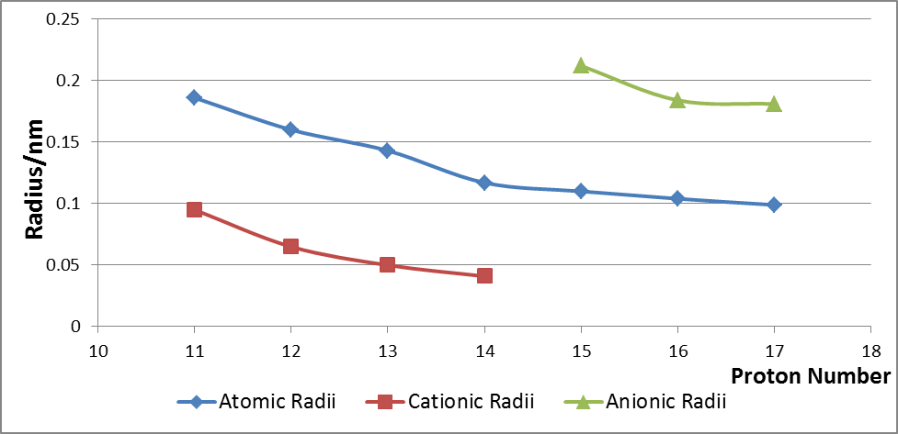
 | (a) | Explain why the atomic radius decreases across the period from Na to Cl.
Across the period from Na to Cl,
- Electrons are added to the same valence shell across the period
- Increase in nuclear charge outweighs negligible increase in screening effect
- Effective nuclear charge increases across the period
- Stronger electrostatic attraction between nucleus and valence electrons
- Valence electrons are progressively pulled closer to the nucleus
- Hence, atomic radius decreases across the period. [2]

 | (b) | (i) | With reference to the cationic radii of Na to Si shown above, indicate, on the graph, the relative positions of the ions, P^{3–}, S^{2–} and Cl–.
 |  | (ii) | Explain your answer to (i).
The anionic radii of P^{3–}, S^{2–} and Cl– are larger than their respective atoms.

- Electrons are added to the same valence shell to form the anion
- Stronger electrostatic repulsion occurs between the electrons, while nuclear charge remains constant
- Weaker electrostatic attraction between nucleus and valence electrons in anion
- Valence electrons are further away from the nucleus [3]
 |  |  |  |  | Explain your answer in (b)(i).
 | (c) | (i) | Write down the electronic configuration of sulfur in its ground state.
 |  |  | 1s²2s²2p⁶3s²3p⁴ or [Ne] 3s²3p⁴
 |  | (ii) | Explain the following phenomenon: Sulfur can react with fluorine to form SF₂, SF₄ and SF₆ but oxygen can react with fluorine to form OF₂ only.
 |  |  | Sulfur is in Period 3 and hence has the availability of 3d orbitals to expand beyond its octet structure while oxygen cannot expand its octet due to the absence of d–orbitals since it is in Period 2
 | [2]
 | [Total: 7]
2 | Ethanoic acid, also commonly known as acetic acid, is an important chemical due to its varied uses in the industry.
 | (a) | The preferred industrial method for its manufacture is by carbonylation of methanol, accounting for 65% of the total world ethanoic acid manufacturing capacity.  CH₃OH(aq) + CO(g) CH₃CO₂H(aq)  The conditions employed are:  - 150 – 200 °C  - 30 – 60 atm  - rhodium–based catalyst
 |  | (i) | Using Le Chatelier’s Principle, explain why the above moderate pressure is chosen as the process condition.
- By Le Chatelier’s Principle, a high pressure will favour the forward reaction to produce higher yield of ethanoic acid.
- However, due to the high cost of equipment needed to withstand the high pressure, it is carried out at a moderate pressure.

 |  | (ii) | In an experiment, the above process is carried out in a V dm³ reaction vessel. 6.80 mol of methanol and 5.50 mol of carbon monoxide are reacted at 180 °C and allowed to reach dynamic equilibrium. 2.00 mol of ethanoic acid is found to be present in the equilibrium mixture. Given that the equilibrium constant, K_{c}, for the reaction is 0.311, determine V.
 | CH₃OH(aq) + CO(g) CH₃CO₂H(aq)
Initial no. of mol | 6.80 | 5.50 | 0
Change in no. of mol | –2.00 | –2.00 | +2.00
Eqm no. of mol | 4.80 | 3.50 | 2.00

K_{c} = = 0.311
V = 2.6124
= 2.61 dm³

 |  | (iii) | The percentage yield of ethanoic acid at different temperatures is shown below.  Temperature Percentage yield  100 °C 70%  200 °C 62%  300 °C 55%  With reference to the data above, deduce whether the carbonylation of methanol is an endothermic or exothermic reaction. Explain your answer.
- Decreasing temperature from 200 °C to 100 °C increases the yield from 62% to 70%. (other comparisons can be made)

- By Le Chatelier’s Principle, decreasing temperature will favour the reaction that is exothermic, to generate heat. Hence, the forward reaction is exothermic.
 |  |  | [5]
 | (b) | The graph below shows the changes in pH when a sample of vinegar, with ethanoic acid as its main component, is titrated against 0.45 mol dm^{–3} aqueous sodium hydroxide.  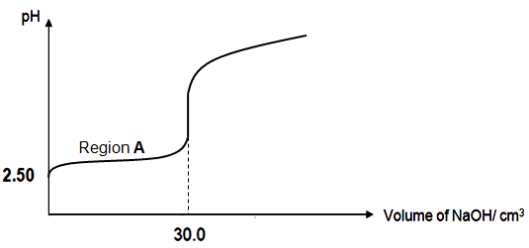
 |  | (i) | Sodium ethanoate is one of the components present in the buffer at region A. Draw a diagram to illustrate the shape in the ethanoate anion. State the shape and bond angles present.
Tetrahedral about C₁ and trigonal planar about C₂.
Bond angles are 109.5° and 120° respectively.
2
1

 |  | (ii) | A claim is made that ethanoic acid is a weak acid, based on its pH of 2.50. Determine, with reasons, the validity of this claim.
 |  |  | The claim is not valid because pH is not an indicator of acid strength. Ethanoic acid can be regarded as a weak acid only if the [H⁺] ≠ [ethanoic acid] or the degree of dissociation is ˂ 1.
 |  | (iii) | A sample of sodium hydroxide is accidentally diluted to an unknown concentration, x mol dm^{–3}. A series of reactions are hence carried out to accurately determine the new concentration.  40.0 cm³ of the diluted aqueous sodium hydroxide solution is reacted with 40.00 cm³ of 0.200 mol dm^{–3} aqueous sulfuric acid. The resulting solution, when reacted with sodium carbonate is found to evolve 35 cm³ of carbon dioxide gas at r.t.p. Determine x.
H₂SO₄ + Na₂CO₃ Na₂SO₄ + CO₂ + H₂O

No. of moles of CO₂ = (35/1000) / 24 dm³ = 1.458 x 10^{–3}

Since H₂SO₄ ≡ CO₂,

No. of moles of excess H₂SO₄ = 1.458 x 10^{–3}
No. of moles of H₂SO₄ initially = 40.00/1000 x 0.200 = 8 x 10^{–3}

2NaOH + H₂SO₄ Na₂SO₄ + 2H₂O

No. of moles of H₂SO₄ reacted = (8 x 10^{–3}) – (1.458 x 10^{–3})
= 6.542 x 10^{–3}
Since 2NaOH ≡ H₂SO₄,

No. of moles of NaOH in 40.0 cm³ = (6.542 x 10^{–3}) x 2
= 1.308 x 10^{–2}

Unknown concentration, x = (1.308 x 10^{–2})/(40.0/1000)
= 0.3271
= 0.327 mol dm^{–3} (3 s.f.)

 |  |  | [6]
 |  |  | [Total: 11]
3 | In a reaction between compounds R and S, the order of reaction with respect to R is one, and the order of reaction with respect to S is two.
 | (a) | Write a rate equation for the reaction and give the units for the rate constant.
Rate equation is rate = k[R][S]²

Units for rate constant, k is mol^{–2} dm⁶ s^{–1} or mol^{–2} dm⁶ min^{–1}

 |  | [2]
Two experiments are carried out to study the effect of temperature on the rate of reaction between compounds R and S. Experiment 1 is carried out at T₁ and the value of rate constant is found to be of 4.20 x 10^{–4}.

Experiment 2 is performed at T₂.

The following table shows the initial concentrations of reactants R and S and initial rates for Experiment 1 and 2 performed at T₁ and T₂ respectively.

Experiment | Temperature | Initial [R] / mol dm^{–3} | Initial [S] / mol dm^{–3} | Initial rate / mol dm^{–3} s^{–1}
1 | T₁ | 0.16 | 0.84 | x
2 | T₂ | 0.64 | 0.84 | 8.10 x 10^{–5}

 | (b) | (i) | Calculate the value of x, the initial rate of reaction of Experiment 1.
rate = k[R][S]²
= 4.20 x 10^{–4} (0.16)(0.84)²
= 4.74 x 10^{–5} (ignore units)

 |  | (ii) | Calculate the value of rate constant at T₂ and hence deduce, with reasoning, which of T₁ and T₂ is the higher temperature.
since rate = k[R][S]²
from experiment 2, 8.10 x 10^{–5} = k(0.64)(0.84)²
k = 1.79 x 10^{–4} (ignore units)
T₁ is at a higher temperature than T₂ [1 with correct reasoning] because rate constant at T₁ (4.20 x 10^{–4}) is of a greater value than that at T₂ (1.79 x 10^{–4})
* Note that these two experiments were done at different initial concentrations AND temperature when usually temperature is held constant in determining the order of reaction with respect to the reactants.
In general, increasing temperature will bring about an increase in rate constant as the frequency of effective collisions increases.]
 |  |  | [4]
 |  |  | [Total: 6]
4 | (a) | Ethanol can be oxidised with acidified potassium dichromate (VI) in the laboratory as shown in Figures 1 and 2 below:  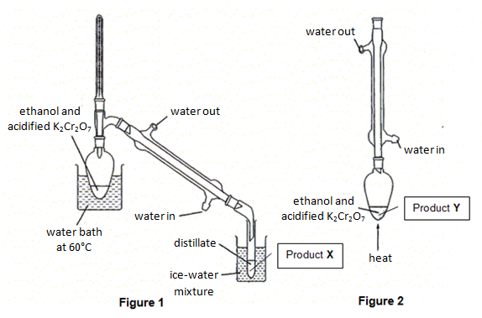
The boiling points of ethanol, ethanal and ethanoic acid are given in the table below:

Compound | Ethanol | Ethanal | Ethanoic acid
Boling point / °C | 78 | 21 | 118

 |  | (i) | Identify the likely product X formed in Figure 1 and explain your answer.
Product X is ethanal.

Explanation
Ethanol is first oxidised to ethanal and since ethanal has the lowest boiling point, it is boiled off first, hence preventing further oxidation, by distillation.

 |  | (ii) | Identify the likely product Y formed in Figure 2 and explain your answer.
Product Y is ethanoic acid.

Explantion
Ethanal is condensed back into the reaction mixture, ie. prevented from escaping, and so it reacts further to give ethanoic acid.

 |  | (iii) | Name the organic impurity that might be present together with product Y in Figure 2.
 |  |  | Ethanal.
 |  | (iv) | To find out the actual yield of product Y, further purification of the product is necessary. Suggest how this can be done.
 |  |  | Redistill the aqueous ethanoic acid (Product Y) and collect the fraction that boils at between 116 °C to 120 °C.
 |  |  | [6]
 | (b) | Gaseous ethanal burns as shown by the following equation:  CH₃CHO(g) + O₂(g) ⎯→ 2H₂O(g) + 2CO₂(g)
 |  | (i) | Using bond energies given in the Data Booklet, calculate the enthalpy change for the combustion of ethanal as shown in the equation above.
enthalpy change for bond breaking = 4(+410) + 350 + 740 + 5/2 (+496)
= 3970 kJ mol^{–1}

enthalpy change for bond forming = 4(+460) + 4(+740)
= 4800 kJ mol^{–1}

enthalpy change of combustion = −830 kJ mol^{–1}
 |  | (ii) | Given that the experimentally determined value for enthalpy change of combustion of ethanal is −1160 kJ mol⁻¹, explain the discrepancy between this value and your answer in (i).
Bond energies quoted in tables represent average (mean) bond energies derived from a full range of molecules containing that particular bond. Hence results from calculations using average bond energies will show discrepancies when compared with results from experiments with specific molecules.
OR
At standard conditions (298K, 1atm), water is in liquid state, the enthalpy change of vaporisation of water should be considered too.
 |  |  | [3]
 |  |  | [Total: 9]
5 | (a) | 2–bromopropane can react with sodium hydroxide in two different ways depending on conditions to give two different products A and B.  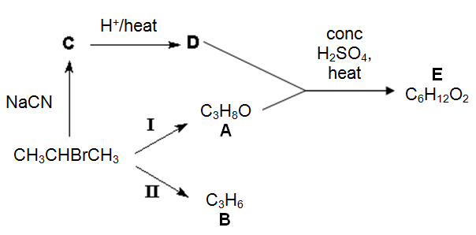
 |  | (i) | Describe the condition(s) necessary for each one of the reactions I and II.  In each case, state the type of reaction undergone.
Reaction I :
Condition: aqueous NaOH, heat
Type of reaction: Nucleophilic substitution

Reaction II:
Condition: alcoholic NaOH, heat
Type of reaction: Elimination

 |  | (ii) | Using the above reaction scheme, draw the structural formulae of compounds C, D and E.
C :

D:

E:
 |  |  | [5]
 | (b) | Suggest a chemical test to distinguish 2–chloropropane, 2–bromopropane and  2–iodopropane, stating clearly the observations made.
Add aqueous sodium hydroxide and heat in waterbath,
(NOT reflux as reflux should not be used in a simple chemical test)
followed by addition of dilute HNO₃ and aqueous silver nitrate.
N.B. r.t.p is optional for the addition of silver nitrate.

Observations:
2–chloropropane: white precipitate is obtained.
2–bromopropane: cream precipitate is obtained
2–iodopropane: yellow precipitate is obtained

 |  | [2]
 |  | [Total: 7]

6(a)  Section B  Answer any two questions on separate answer paper. | Chlorine and its compounds are used to manufacture many products such as pesticides, medicines, plastics, bleaches and solvents. Many chlorine compounds are also used extensively in organic chemistry.
 | (i) |  | 1 mol of AlCl₃ and SiCl₄ is added to 1 dm³ of water.  Describe with appropriate equations for the reaction of these chlorides with water. What is the effect of adding universal indicator to the resulting solution?
SiCl₄ + 2H₂O ⎯→ SiO₂ + 4HCl
AlCl₃ + 6H₂O ⎯→ [Al(H₂O)₆]³⁺ + 3Cl⁻
[Al(H₂O)₆]³⁺ [Al(H₂O)₅(OH)]²⁺ + H⁺

Universal indicator turns red for SiCl₄ and turns orange for AlCl₃

 | (ii) |  | With the aid of an equation, define the second ionisation energy of chlorine.
The second I.E is the energy required to remove one mole of electrons from one mole of singly positively charged gaseous chlorine ions to form one mole of doubly positively charged gaseous chlorine ions.

Cl⁺ (g) ⎯→ Cl ²⁺ (g) + e– [4]
(b) | Give the structure of the organic product when compound E is reacted with each of the following reagents.
 | (i) |  | warm aqueous sodium hydroxide
 | (ii) |  | 2,4–dinitrophenylhydrazine
 | (iii) |  | hot acidified potassium chromate (VI)
 |  |  | [3]
(c) | Describe the variation in melting points of the chlorides of the elements from sodium to phosphorus and explain the variation in terms of structure and bonding.
– Melting points of NaCl and MgCl₂ are higher than that of Al₂Cl₆, SiCl₄ and PCl₃/PCl₅.

– This is because NaCl and MgCl₂ have giant ionic lattice structures and a larger amount of heat/energy is required to overcome the strong electrostatic forces of attraction between the ions resulting in high melting points.

– Al₂Cl₆, SiCl₄ and PCl₃/PCl₅ have simple molecular structure with weaker van der Waals forces between the molecules (or intermolecular) so their melting points are lower than the ionic NaCl and MgCl₂.

– Melting point: SiCl₄ ˂ PCl₃/PCl₅ ˂ Al₂Cl₆
The ease of distortion of electron cloud increases due to the increase in number of electrons, hence, strength of intermolecular van der Waals’ forces increases from SiCl₄ to PCl₅ to Al₂Cl_{6.}
[4]
(d) | PCl₅ is commonly used for substitution reactions in organic chemistry.  Compound A, with molecular formula C₄H₈O₃, reacts with PCl₅ to give white fumes. A gives a yellow precipitate when it is warmed with aqueous alkaline iodine solution. When a solution containing A is warmed with aqueous sodium hydroxide, compounds B and C are formed. Upon acidification of the resulting mixture, compound B, C₃H₆O₃, can be isolated. When B is warmed with concentrated sulfuric acid, a cyclic compound D, C₆H₈O₄, is formed.  Compound E is a structural isomer of B. When E is warmed with concentrated sulfuric acid, a non–cyclic compound F, C₃H₄O₂, is produced.  Deduce the structures of compounds A, B, C, D, E and F. Explain the chemistry of the reactions described.
A undergoes nucleophilic substitution reaction with PCl₅
⇒ alcohol or carboxylic acid present in A

A undergoes oxidation with aqueous alkaline iodine
⇒ present in A

A undergoes alkaline hydrolysis when heated with NaOH
⇒ ester is present in A.

B undergoes (self) - esterification when heated with conc. H₂SO₄ to give ester D.

E undergoes dehydration/elimination with conc. H₂SO₄ to from F
⇒ alkene present in F.

Structure of A: Structure of B:

Structure of C: Structure of D:
CH₃OH

Structure of E: Structure of F:

[9]

 |  | [Total: 20]

7(a) | Compound G has the following composition by mass:  C, 31.9%; H, 5.3%; Cl, 62.8%.
 | (i) | Given that the relative molecular mass of compound G is 113.0, determine its molecular formula.  C H Cl  % by mass 31.9 5.3 62.8  Ar 12.0 1.0 35.5  No. of moles 2.66 5.30 1.77  Mole ratio 1.5 ≈ 3 3 ≈ 6 1 ≈2  Empirical formula: C₃H₆Cl₂  Let the molecular formula be (C₃H₆Cl₂)_{n}.  n(3 x 12.0 + 6.0 + 2 x 35.5) = 113.0  n = 1  Hence, molecular formula is C₃H₆Cl₂
 | (ii) | Draw all the structural isomers of compound G and identify the type of structural isomerism present.
Type of isomerism: Positional isomerism

1,2–dichloropropane | 1,1–dichloropropane
1,3–dichloropropane | 2,2–dichloropropane

 | (iii) | Compound H with molecular formula, C₄H₈, can be oxidised by cold dilute alkaline KMnO₄ to form compound I which has a positive iodoform test with alkaline aqueous iodine. Deduce the structural formulae of compounds H and I.
Compound H Compound I

CH₃CH=CHCH₃ CH₃CH(OH)CH(OH)CH₃
[8]
(b) | 40.0 cm³ of 3.00 mol dm^{–3} methanoic acid, HCOOH, is added to 60.0 cm³ of  1.40 mol dm^{–3} potassium hydroxide in a polystyrene cup. The maximum temperature rise is recorded as 8.5 ºC.  Given that the specific heat capacity of the solution is 4.20 J g^{–1} K^{–1},
 | (i) | Define what is meant by the standard enthalpy change of neutralisation.
 |  | Standard enthalpy change of neutralisation (ΔH_{n}^{θ}) is the energy change / evolved when one mole of water is formed from the neutralisation between acid and alkali under standard conditions.
 | (ii) | Write a balanced chemical equation for the neutralisation of methanoic acid with potassium hydroxide.
 |  | HCOOH (aq) + KOH (aq) ⎯→ HCOO–K⁺ (aq) + H₂O (l)
 | (iii) | Given that the process was 80% efficient, calculate the standard enthalpy change of neutralisation for the reaction in (ii).
HCOOH (aq) + KOH (aq) ⎯→ HCOO–K⁺ (aq) + H₂O (l)

No. of moles of HCOOH = 40/1000 x 3 = 0.1200
No. of moles of KOH = 60/1000 x 1.4 = 0.08400
⇒ KOH is the limiting reagent.

Q’ = mcΔT
= 100 x 4.2 x 8.5
= 3570 J

Q = 3570/80 x 100
= 4462.5 J
ΔH_{n}^{θ} =
= –4462.5 / 0.084
= –53125
= 53100 J mol^{–1} or –53.1 kJ mol^{–1}

 | (iv) | How would you expect the enthalpy change calculated in (iii) to compare with the enthalpy change of neutralisation of nitric acid with potassium hydroxide? Explain your answer.
The enthalpy change of neutralisation involving HCOOH and KOH is less exothermic than enthalpy change of neutralisation involving HNO₃ and KOH.

Some of the energy evolved from the neutralisation process is used to further dissociate the weak acid completely / to cause ionisation of the undissociated weak acid.
[8]
(c) | (i) |  | Refractory material is used to line the interior of a furnace because of its high melting point and low reactivity. By comparing the lattice energy of calcium nitride, Ca₃N₂ and beryllium nitride, Be₃N₂, predict and explain which compound would make a better refractory material.
|ΔH_{latt} | α
Since both cations have a charge of +2 and ionic radius of Be²⁺ < Ca²⁺

|ΔH_{latt} (Be₃N₂) | > |ΔH_{latt} (Ca₃N₂) |
OR ΔH_{latt} (Be₃N₂) is more exothermic than ΔH_{latt} (Ca₃N₂)

Electrostatic forces of attraction between Be²⁺ and N^{3–} ions are stronger than that between Ca²⁺ and N^{3–} ions.

Melting point: Be₃N₂ > Ca₃N_{2.}

Be₃N₂ is a better refractory material.

 | (ii) |  | Be₃N₂ is found to react similar to a Period 3 nitride. Suggest, with reasons, whether Be₃N₂ reacts with acids, bases or both. Hence, name the Period 3 nitride that has similar chemical properties.
Be₃N₂ reacts with both acids and bases because it is amphoteric.

Aluminium nitride, AlN.
[4]
 | [Total: 20]

8(a) | Propanoic acid and citric acid (C₅H₇O₄COOH) are some of the monobasic acids used in the formulation of hair shampoo. A chemistry student wanted to formulate a shampoo with maximum buffer capacity so that there will be minimal damage to the hair.  In an attempt to prepare a buffer for the shampoo, she titrated 20.0 cm³ of 0.100 mol dm^{–3} sodium hydroxide against 0.20 mol dm^{–3} citric acid.
 | (i) | Explain, with the aid of an equation, why propanoic acid is a stronger acid than propanol.
CH₃CH₂COOH CH₃CH₂COO– + H⁺

- Lone pair electrons of oxygen of the carboxylate ion can interact with the carbonyl group. This stabilises the carboxylate anion (RCOO–) by the dispersion of negative charge over two oxygen atoms.

- The dispersion of charge over two oxygen atoms stabilises the carboxylate anion to a greater extent than in the alkoxide ion.

- This explains why propanoic acid is a stronger acid than propanol.

 | (ii) | Calculate the pH of 0.100 mol dm^{–3} sodium hydroxide.
pOH= –log [OH–] = – log (0.1) = 1
pH = 14–1 = 13
 | (iii) | Calculate the volume of citric acid required to completely neutralise 20.0 cm³ of sodium hydroxide.
No. of moles of NaOH = 20/1000 x 0.1 = 0.002
Citric acid ≡ NaOH
Volume of citric acid = 0.002 / 0.2 = 10.0 cm³

 | (iv) | When excess citric acid is added, a buffer solution is obtained.  Explain, with the aid of equations only, how the mixture can act as a buffer upon addition of a small amount of acid and alkali.
When H⁺ is added,
H⁺ + C₅H₇O₄COO– → C₅H₇O₄COOH

When OH– is added,
C₅H₇O₄COOH + OH– → C₅H₇O₄COO– + H₂O
 | (v) | Suggest, with appropriate reasoning and equations, if the same volume of hydrogen gas will be produced if propanoic acid and hydrochloric acid, of the same concentration and volume are to react with 2.0 g of zinc metal under the same condition.
- CH₃CH₂COOH ⇌ CH₃CH₂COO– + H⁺
- HCl H⁺ + Cl–
- 2H⁺ + Zn Zn²⁺ + H₂
Same volume of H₂ gas will be produced in both cases since no. of moles of acid is the same.
Since H⁺ reacts with zinc, for (1), [H⁺] will decrease and by Le Chatelier’s Principle, equilibrium position of (1) will shift right, hence all CH₃CH₂COOH will be reacted eventually producing the same amount of H₂ gas.

 | (vi) | Propanoic acid can be made more acidic by introducing chlorine substituents. By clearly stating the name of the mono–substituted acid, suggest why it is the most acidic compared to its isomers.
2–chloropropanoic acid.

The electron–withdrawing chlorine atom stabilises the carboxylate the most since it it the closest to the COO– group.
[12]
(b) | Glycolic acid is the smallest α–hydroxy acids (AHAs). It is also one of the main ingredients used in the manufacture of skin care products due to its excellent capability to penetrate human skin.  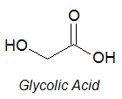
 | (i) | Show how glycolic acid can be synthesised from methanol via three steps. In your answer, show clearly the reagents, conditions and intermediates involved.
Step 1
[1]
Reagents: acidified K₂Cr₂O₇
Conditions: heat with distillation

Step 2
[1]
Reagents: HCN with trace amount of
NaOH / NaCN
Conditions: cold 10 – 20 ºC

Step 3
Reagents: aq HCl / aq H₂SO₄
Conditions: Heat/ reflux

 | (ii) | Explain, with the aid of a diagram, why the relative molecular mass of glycolic acid is 152 when dissolved in a suitable solvent.
Dimerisation has occurred.

[8]

 | [Total: 20]

